**10th Annual**

**Robbie Mills Memorial**

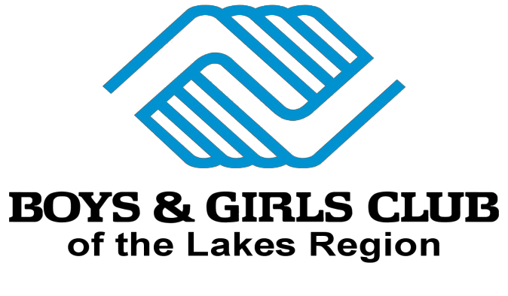

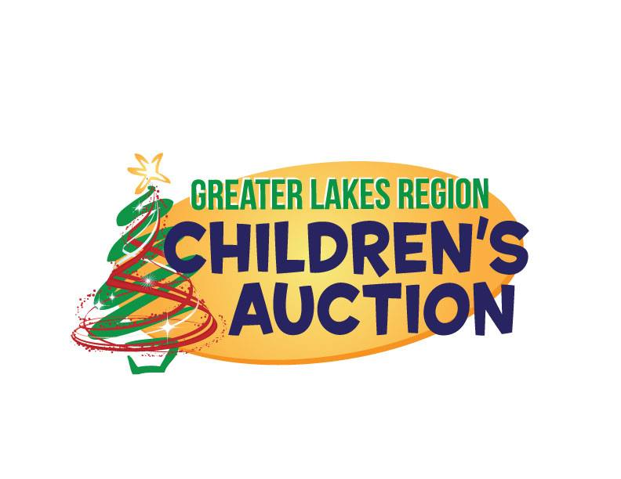

To Benefit: &



**Saturday March 11th** (Major Snow date March 12th)

**at Rod & Gun Club Laconia**

**358 South Main Street**

$25.00 PP Donation includes: Practice, Lunch & entry for door prizes

Pre-Pay by March 1st and receive a free T-Shirt Doors open @ 9:30am (Pay $30.00 after 10:30) Tournament starts Promptly at 11:00am

Double Elimination - BCA Rules apply

Sponsor a player: If you can’t play, Pay for a player that can’t afford it!

Pre-Pay at [www.robbiemills.org](http://www.robbiemills.org)

for information

Contact Tony Felch 998-1418

Or Mike Baron 528-5001 or on

Robbie Mills website at [www.robbiemills.org](http://www.robbiemills.org)

Trophies

 Cash Prizes  Food

 Raffles  50/50

 Live Auction

Sponsored by



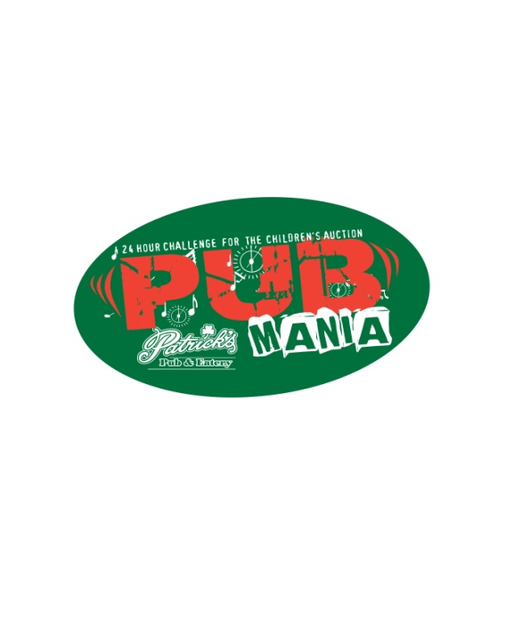

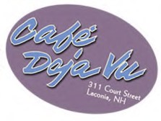&

TEAM